Lower Clark Fork Tributaries

Watershed Restoration Plan

2019
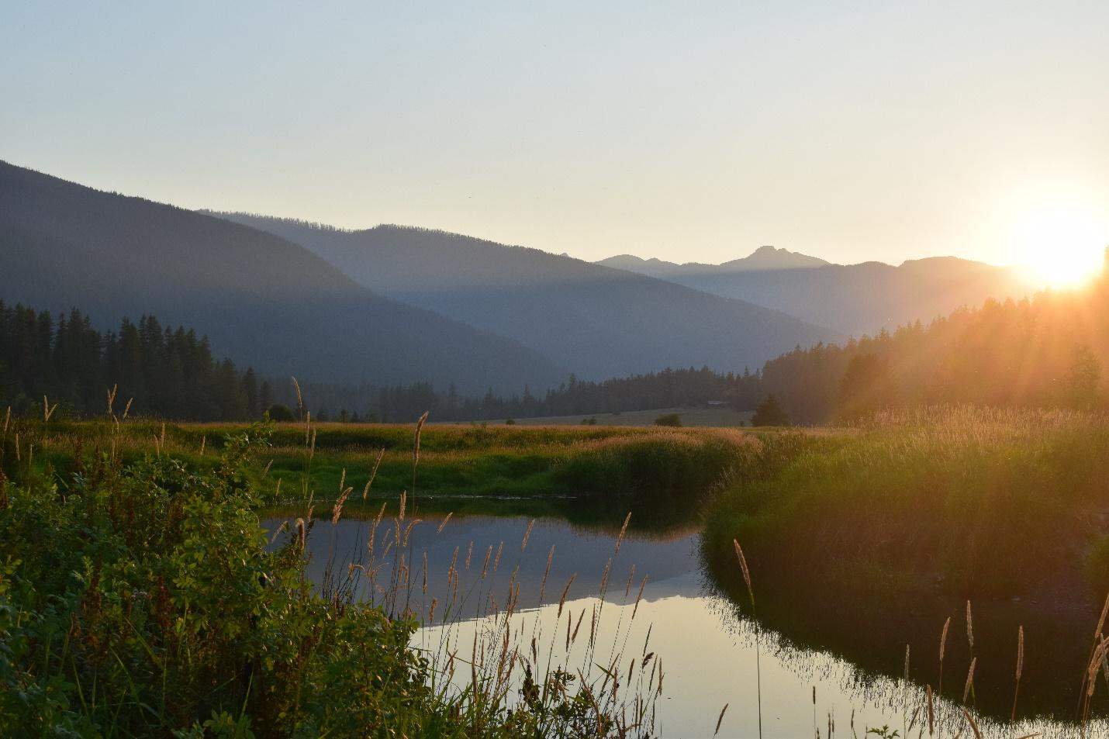
View from 8 Mile Bridge, Bull River. Photo Credit: Mariah R. Williams

Acknowledgements:
Lower Clark Fork Watershed Group (LCFWG) has taken the lead in organizing and drafting the Lower Clark Fork Tributaries Watershed Restoration Plan, but the completion of this plan was only possible with the contribution of many local stakeholders throughout the Lower Clark Fork Watershed.

Authors:
Sarah Bowman – Lower Clark Fork Watershed Group
Brita Olson – Lower Clark Fork Watershed Group

Contributing Stakeholders:
Avista: Sean Moran
Bull River Watershed Council: Kathy Ferguson
Lower Clark Fork Watershed Group: Brita Olson, Ruth Watkins, Regan Plumb, Sarah Bowman, Ryan Kreiner, Sean Moran
Montana Department of Environmental Quality: Eric Trum
Montana Fish, Wildlife, and Parks: Jason Blakney, Ryan Kreiner
Rock Creek Resources: Ed Kline
Soil and Water Conservation Districts of Montana: Samantha Tappenbeck
Trout Unlimited: Christine Brissette
United States Forest Service – Kootenai National Forest: Doug Grupenhoff, Craig Neesvig
United States Forest Service – Lolo National Forest: Jon Hanson

Funders:
Avista
Bureau of Reclamation
Montana Department of Natural Resources and Conservation
Watershed Management Grant Program
223 Program

Table of Contents

Section 1: Introduction
1.1: Watershed Restoration Plans
1.2: Impaired Streams and Total Maximum Daily Loads
1.3: Causes and Sources of Impairments
1.4: Additional Streams and Water Quality Management Considerations
1.5: Lower Clark Fork Tributaries Watershed Restoration Plan Goals and Objectives

Section 2: Lower Clark Fork Tributary Watersheds
2.1: LCF Watershed Characterization
2.2: Beaver Creek Watershed
2.3: Blue Creek Watershed
2.4: Bull River Watershed
2.5: Elk Creek Watershed
2.6: Graves Creek Watershed
2.7: Marten Creek Watershed
2.8: Pilgrim Creek Watershed
2.9: Prospect Creek Watershed
2.10: Rock Creek Watershed
2.11: Swamp Creek Watershed
2.12: Trout Creek Watershed
2.13: Vermilion River Watershed
2.14: Additional Tributaries

Section 3: Recommended Best Management Practices, Restoration, and Expected Pollutant Reductions
3.1: Best Management Practices and Restoration
3.2: Load Allocations and Expected Pollutant Reductions

Section 4: Available Resources
4.1: Technical Resources
4.2: Financial Resources

Section 5: WRP Development and Priorities for Restoration
5.1: WRP Development Process
5.2: Priorities for Restoration
5.3: Adaptive Management – Shifting Priorities in the Face of Future Climate Change

Section 6: Progress Evaluation

Section 7: References

Acronyms
BLT: Bull Trout
BMP: Best Management Practice
BPA: Bonneville Power Administration
CFSA: Clark Fork Settlement Agreement
CWA: Clean Water Act
DEQ: [Montana] Department of Environmental Quality
DNRC: [Montana] Department of Natural Resources and Conservation
EIS: Environmental Impact Statement
EPA: Environmental Protection Agency
FSR: Forest Service Road
FWP: [Montana] Fish, Wildlife, and Parks
GMCD: Green Mountain Conservation District
LCF: Lower Clark Fork [River]
LCFR-LPO: Lower Clark Fork River—Lake Pend Oreille [system]
LCFWG: Lower Clark Fork Watershed Group
LWD: Large Woody Debris
MCA: Montana Climate Assessment
MDT: Montana Department of Transportation
MFISH: Montana Fish Information System
MWCC: Montana Watershed Coordination Council
MWF: Mountain Whitefish
MTNHP: Montana Natural Heritage Program
NFS: National Forest System
NPS: Nonpoint Source [Pollution]
NRCS: Natural Resources Conservation Service
NWE: Northwestern Energy
RHCA: Riparian Habitat Conservation Area
RKM: River Kilometer
RM: River Mile
SMZ: Streamside Management Zone
SWCDM: Soil and Water Conservation Districts of Montana
TAC: Technical Advisory Committee
TMDL: Total Maximum Daily Load
TN: Total Nitrogen
TP: Total Phosphorus
USFS-IPNF: United State Forest Service – Idaho Panhandle National Forest
USFS-KNF: United States Forest Service - Kootenai National Forest
USFS-LNF: United States Forest Service - Lolo National Forest
USFWS: United States Fish and Wildlife Service
WCT: Westslope Cutthroat Trout
WRP: Watershed Restoration Plan
WRTAC: Water Resources Technical Advisory Committee
YPL: Yellowstone Pipeline

Section 1: Introduction

1.1: Watershed Restoration Plans

A watershed restoration plan (WRP) is a locally developed document that provides a framework for managing, protecting, and restoring local water resources. Creating a plan is one of the requirements to receive grant funding under Section 319 of the federal Clean Water Act (CWA). The CWA, passed by congress in 1972 to be implemented by the Environmental Protection Agency (EPA), establishes the basic structure for addressing discharges of pollutants into waters of the United States and its major goal is to “restore and maintain the chemical, physical, and biological integrity of the Nation’s waters” (DEQ 2006, 2009, 2010, 2014b). Pollutants are generally separated into two types: point sources and nonpoint sources.

Point sources, defined as pollution that comes from a single source, are regulated through discharge permits acquired from the Montana Department of Environmental Quality (DEQ). These permitted points of pollutant discharge are typically associated with factories, wastewater treatment plants, or other industries. The CWA has been successful in reducing the impacts of point source pollution through this permitting process (DEQ 2017).

Nonpoint source (NPS) pollution comes from a variety of diffuse sources and is transported by runoff (i.e., rainfall or snowmelt moving over and through the ground). Runoff picks up and transports natural and human-caused pollutants, and ultimately deposits them into lakes, rivers, wetlands, and groundwater (DEQ 2017). Nonpoint source pollution is addressed by natural resource managers, landowners, and community members through a combination of both regulatory and voluntary actions. Watershed Restoration Plans help guide voluntary actions to holistically address NPS pollution by providing an assessment of the contributing causes and sources of NPS pollution for a specific watershed and setting priorities for implementing step-wise management actions to prevent or reduce NPS pollution (DEQ 2017).

In Montana, DEQ administers and distributes CWA Section 319 project funding to government or nonprofit organizations (such as watershed groups) to address NPS pollution in accordance with accepted WRPs. Acceptance of individual WRPs is contingent on the presence of nine key elements developed by the EPA (DEQ 2017). Information pertaining to each of these elements can be found in the sections of this document identified parenthetically after each element as listed below.

- Identify NPS pollutant causes and sources (Sections 1 & 2)
- Estimate NPS pollutant loading into the watershed and expected load reductions (Section 3)
- Describe NPS management measures to achieve load reductions (Section 3)
- Estimate technical and financial assistance needed to implement the plan (Section 4)
- Develop an information/education component (Section 5)
- Develop a NPS management implementation schedule (Section 5)
- Describe measurable milestones (Section 6)
- Identify indicators to measure progress and effectiveness (Section 6)
- Develop a monitoring component to evaluate implementation effectiveness (Section 6)

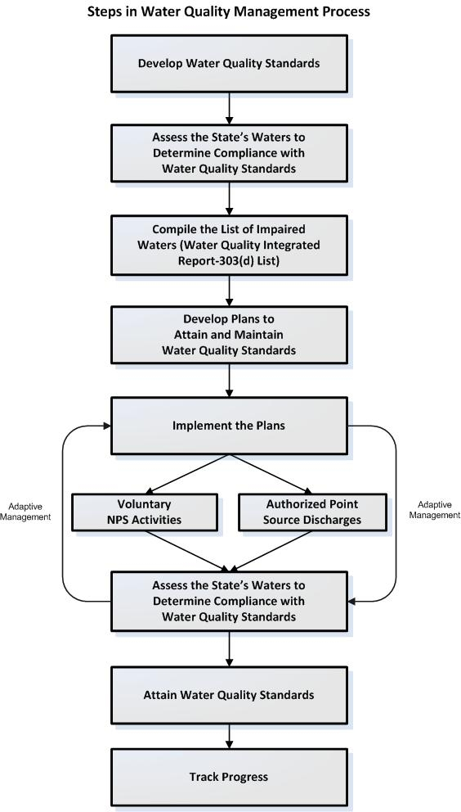
1.2: Impaired Streams and Total Maximum Daily Loads

Figure 1A. Montana DEQ’s Adaptive Water Quality Management Process. Source: DEQ

Figure 1.2A. Montana DEQ’s Adaptive Water Quality Management Process (DEQ 2017).

The CWA requires that each state designate beneficial uses of their waters and develop water quality standards to protect those uses. In Montana, the water quality beneficial use classification system includes: agriculture, drinking water, fish and aquatic life, industry, recreation, and wildlife (DEQ 2017).

Once a water body fails to meet one or more water quality standard, it is identified as impaired and no longer fully supporting its designated beneficial use. Montana DEQ updates a Water Quality Integrated Report every two years which identifies impaired streams and associated pollutants (DEQ 2017). After a stream has been identified as impaired, both Montana state (75-5-701 of the Montana Water Quality Act) and federal law (Section 303(d) of the CWA) require development of total maximum daily loads (TMDLs), defined as the maximum amount of pollutants that a waterbody can receive and still meet water quality standards. TMDLs are published in a document which identifies impaired streams, the pollutants impairing those streams, current water quality standards, and general strategies for reducing NPS pollutant loads (DEQ 2017). WRPs are then developed to guide step-wise, locally driven action that addresses impairments identified in a TMDL document. Figure 1.2A illustrates DEQ’s Adaptive Water Quality Management Process (DEQ 2017).

1.3: Causes and Sources of Impairments

A “cause of impairment” refers to the pollutant that prevents the waterbody from meeting water quality standards. Sediment, temperature, and metals are the pollutant causes of impairment within the Lower Clark Fork (LCF) Tributary Watershed Restoration Planning Area that are addressed by this WRP. A “source of impairment” refers to the activity or entity from which a pollutant is derived, such as streambank modification or loss of riparian habitat. In addition to the primary pollutant causes of impairments, there are non-pollutant causes, such as alteration in streamside vegetation, that affect stream structure and function, and are therefore important management concerns. Unlike primary pollutant causes, these non-pollutant causes primarily relate to habitat and have no calculated loads (DEQ 2006, 2009, 2010, 2014b). Additional information about specific causes and sources of pollutants and non-pollutants for impaired waterbodies in Montana can be found on Montana’s CWA Information Center website.

Sediment Causes and Sources

Erosion, sedimentation, and sediment transport are natural processes important to building and maintaining streambanks, floodplains, and quality aquatic habitat. However, excessive amounts or accelerated rates of sedimentation and erosion due to human activities creates unnaturally high levels of sediment, streambed aggradation, channel incision, and bank erosion that impairs stream health and beneficial uses in the following ways (DEQ 2009, 2010):
- Causes unnatural acceleration of erosion and land loss.
- Increases turbidity, reduces light penetration, and creates murky and discolored water, which limits aquatic plant growth, and also can decrease recreational experiences and aesthetic appreciation of the stream.
- Obscures sources of food, habitat, hiding places, and nesting sites, which impairs reproduction and survival of aquatic organisms.
- Clogs fish gills and causes abrasive physiological damage, reduces availability of suitable spawning sites, smothers eggs or hatchlings, hinders emergence of newly hatched fish, depletes oxygen supplies, and causes accumulation of metabolic waste around developing embryos.
- Reduces the quality of fishery available for recreational use and guiding commodity.
- Increases filtration costs for water treatment facilities that provide safe drinking water.
- Increases flooding frequency in areas of aggradation.
- Increases maintenance and replacement costs to roads and other infrastructure within flood-prone areas.

Major sources of sediment include:

Streambank Erosion: Streambank erosion occurs naturally as a result of streams shifting across the landscape and cutting new paths by which to flow. However, human disturbances to riparian vegetation, road encroachment, or altered stream hydrology can accelerate natural rates. Accelerated erosion often results from instability caused by partial or complete removal of riparian and streamside vegetation, loss of channel capacity, channel incision, or impairment of natural meandering pattern and processes. Reductions in streamside vegetation is commonly associated with the roadway footprint occupying space that otherwise would be inhabited with large trees, prominent shrubs, forbs, and grasses (DEQ 2009, 2010). Other activities such as historic road construction and maintenance practices, historic wildfires, historic riparian timber harvest prior to the Montana Streamside Management Zone Law (SMZ), livestock over-grazing, and mining can also damage or eliminate streamside vegetation and accelerate streambank erosion.

Upland Erosion: Upland sediment originates beyond the stream channel and is caused when ground cover is disturbed and unprotected. Detached soil particles are transported to streams typically through overland flow, groundwater flow, or even by wind. Erosion and subsequent sediment loading to the stream via upland erosion are influenced by land use, type and extent of vegetative cover, and, particularly, the quality of riparian buffers (DEQ 2009, 2010). While natural sources contribute a considerable portion of the sediment load, activities that disturb the soil surface, such as grazing, agriculture, unmitigated timber harvest, roads, or wildfire can also influence sediment loading to streams (DEQ 2009, 2010).

Roads: Roads are routes of compacted soil that act as sources of overland flow. Roads can intercept groundwater and convert it to surface flow. This surface flow then picks up and carries sediment as it flows over open roads, and can be directly delivered to the stream channel where roads cross streams (USFS 2013). Roads crossing stream channels or running parallel to stream channels also degrade and replace riparian vegetation, preclude trees and recruitment of trees that would otherwise provide shade and stream habitat, encroach on the channel, limit natural stream meandering processes, and contribute sediment directly to the stream. Factors influencing sediment contributions from roads include proximity to the stream, road type, construction specifications, maintenance, drainage, soil type, topography, and precipitation frequency and intensity. Culverts that are undersized, improperly installed, or insufficiently maintained can increase erosion, sediment loading, and preclude movement and propagation of fish. Most sediment loading comes from short, limited sections of roads that encroach on riparian areas immediately adjacent to streams, and a number of road crossings with inadequate size or improper maintenance. Additionally, road maintenance, including winter plowing and application of traction sand may produce an additional sediment load to stream channels (DEQ 2009, 2010).

Temperature Causes and Sources

Human influences that reduce stream shade, increase stream channel width, add heated water, or decrease the capacity of the stream to buffer incoming solar radiation all increase stream temperatures. As a result, these warmer temperatures negatively affects aquatic wildlife that depend on cool water for survival. Specifically, coldwater fish species are particularly stressed by warmer water temperatures, which often results in reduced dissolved oxygen levels and direct metabolic impacts (DEQ 2014b). Elevated temperatures boost the ability of non-native fish to outcompete native fish if the native species are unable to adapt. Stream temperatures are naturally highest during the summer months due to greater solar insolation, increased water use for irrigation, and natural summer decrease of flow volume. Human activities can cause stream temperatures to rise when they:
- Reduce stream shade (reduce amounts of riparian vegetation);
- Increase stream channel width (change the width/depth ratio); and
- Take water out of the stream (Water use and alteration of instream flow).

Loss of Riparian Shade: Riparian vegetation provides shade to stream channels, which reduces the amount of sunlight hitting the stream, and ultimately reduces the thermal load to the stream. Riparian vegetation also reduces near-stream wind speed and traps air against the water surface, which reduces the rate of heat exchange with the atmosphere (DEQ 2014b).

Width to Depth Ratio: When channel width increases relative to depth as a result of human activities and erosion, the channel loses its ability to stay cool due to an increase in surface area exposed to the sun and warm air. A channel with a lower width to depth ratio (deep water relative to channel width) has less surface area in contact with the air and is slower to absorb heat during periods of warm temperatures. Additionally, the riparian canopy shades a larger percentage of the water surface area of narrow channels (DEQ 2014b).

Instream Flow and Water Use: Due to the physical properties of water, more time and energy (solar radiation) is required to heat larger volumes. As a result, when instream flows are reduced, such as by irrigation draw-downs, the ability of the stream to buffer incoming solar radiation is reduced. A stream channel with less water will heat up much faster than a channel with more water and identical morphology and shading conditions (DEQ 2014b).

Metals Causes and Sources

Existing metal concentrations (antimony, arsenic, lead, and zinc) in streams is typically dependent upon the geology of the watershed. If metal materials are present on the landscape, then it can be assumed that any existing metal concentrations in streams could be there naturally due to the flow of water over and through those metal materials. Specifically, stibnite veins occur at or near the surface of a couple of impaired streams within the LCF watershed and are known conduits for groundwater flow, as many vein locations are marked by the presence of springs (DEQ 2006). Additionally, many veins are reported to contain arsenic “blooms”, a green arsenic oxide mineral, the presence of which suggest that oxidation of the sulfide ore has occurred, which typically is accompanied by natural leaching of metals to the environment (DEQ 2006).

However, mining activities can cause these metals concentrations to become excessive beyond natural background levels. Streams with metals concentrations exceeding the aquatic life and/or human health standards can impair numerous beneficial uses, including aquatic life and drinking water, and can cause a number of other issues, including:
- Having toxic, carcinogenic, or bioconcentrating effects on aquatic organisms.
- Causing acute and chronic health problems for humans and wildlife from consuming metal contaminated drinking water or fish tissue.
- Having toxic effects on agricultural crops and livestock from irrigation of metal contaminated water (DEQ 2006)

Non-Pollutant Causes and Sources

Non-pollutants are defined as a human-caused change in the environment that affects the waterbody or its biological community (DEQ 2016). These habitat related non-pollutants are often linked with sediment, temperature, or metals issues, or may be having a negative effect on a beneficially use, without clearly defined quantitative measurements or direct links to a pollutant to describe that impact (DEQ 2010). However the issues associated with these non-pollutants are still important to consider when attempting to improve water quality conditions in individual streams, even if TMDL development is not required for them. Non-pollutant listings are often used as a probable cause of impairment when available data at the time of assessment does not necessarily provide a direct quantifiable linkage to a specific pollutant. They can be listed as linked to a specific pollutant or listed independently (DEQ 2010). While non-pollutants do not require TMDL development, the issues associated with these non-pollutants are still important to consider when attempting to improve water quality conditions in individual streams.

Alteration in Stream-side or Littoral Vegetation Covers: This non-pollutant refers to circumstances where practices along the stream channel have altered or removed riparian vegetation, affecting the channel geomorphology and/or stream temperature. This causes banks to become unstable due to loss of vegetative root mass, over-widened channels, elevated sediment loads, and increased water temperatures due to lack of canopy cover (DEQ 2010).

Physical Substrate Habitat Alterations: This non-pollutant generally describes situations where the stream channel has been physically altered, such as through the straightening of the channel or from human-caused channel downcutting, resulting in a reduction of morphological complexity and loss of habitat (riffles and pools) for fish and aquatic life (DEQ 2010).

Other Anthropogenic Substrate Alterations: This non-pollutant refers to situations where data indicates that impacts to the stream have occurred as a result of anthropogenic activities, but parameters related to sediment do not appear high, and morphological characteristics are also within expected values. For example, this non-pollutant impairment could occur on streams where historic or current reduction of vegetation capable of producing large woody debris has occurred. This would result in a lack of large woody debris in the stream channel which is integral to pool development and channel function in most streams (DEQ 2013).

Chlorophyll-a: Chlorophyll-a or algae in the stream can impair aquatic life and is caused by excess concentrations of nutrients in the stream, which increases algal biomass (DEQ 2014a).

1.4: Additional Stream and Water Quality Management Considerations

In addition to the 16 DEQ-listed tributary streams included in this WRP, additional tributaries may also be included. Although not included on the 303(d) list of impaired streams, opportunities may exist to protect, maintain, enhance, or restore water resources, fisheries populations and fish habitat, or to reduce potential threats to a stream’s ability to continue to support beneficial uses into the future. Including additional streams, where there are opportunities and local impetus (beyond 303(d) listing) for watershed improvement work, helps make a WRP a more comprehensive plan for restoration throughout an entire watershed and a more meaningful reflection of all stakeholder priorities. Therefore, additional water quality restoration strategies are considered in conjunction with NPS pollution reduction guidelines.

Additional management considerations in the LCF watershed that have informed this plan have focused primarily on native salmonid management and conservation (specifically Bull Trout and Westslope Cutthroat Trout).

Management techniques intended to improve native salmonid habitat focus on supporting resilient populations into the future. Restoration efforts that reduce NPS pollution and improve fish habitat will also contribute to overall watershed health. In addition to direct water quality impacts from sediment and nutrient loading and high stream temperatures, there are a number of factors that limit native fish population growth in northwestern Montana. In the tributaries of the LCF watershed, contributing factors include habitat degradation and non-native species interactions.

Habitat Degradation: Historic and ongoing human activities such as road construction, logging, grazing, and mining have degraded and fragmented habitats, reducing connectivity of streams and rivers with resident native fish populations. Both Westslope Cutthroat Trout and Bull Trout are cold-water species and require cool, clear, fast-running streams for adequate spawning and rearing habitat (USFWS 2015). Streams that have become wider and shallower or simplified from lack of wood or meander bends, contain fewer large deep pools, and therefore have lost habitat complexity under which native fish populations evolved and adapted. Large woody debris (LWD) is an important factor in healthy streams because it reroutes sediment and water, creating a complexity of niches, drives the natural formation and placement of pools, riffles, and cover, and acts as a substrate for biological activity. Loss of LWD inhibits the stream’s ability to reduce stream velocities, and in addition, reduces habitat complexity and shade, which are critical to the life cycle of native fish populations (USFS 2013). Other events or activities that threaten native salmonid populations and degrade habitats include: large stand replacement forest fires, landslides resulting from local geology or rain on snow events, and low flows or intermittent streams (GEI 2005).

Non-Native Species Interactions: Non-native fish species, such as Brown Trout, Brook Trout, and Rainbow Trout, are the principal species of concern interacting with native salmonids in tributary streams to the LCF River. All three of these species were introduced to the LCF watershed throughout the 20th century, and they cause issues such as superimposing on native trout redds during spawning, hybridization (specifically between Brook and Bull Trout), and interspecies competition (GEI 2005). Non-native and hybridized species are often better adapted to habitat conditions and compete with native populations when they occur together, even in un-degraded habitats (USFWS 2015, McMahon et al. 2007). Climate change also poses a significant threat to many native salmonid species in the LCF watershed, especially to Bull Trout as they have substantially colder thermal tolerances than most salmonids (Al-Chokhachy et al. 2016). Climate change drives the distribution of non-native fish species, such as Brown Trout, to displace native salmonid species (Al-Chokhacky et al. 2016).

1.5: Lower Clark Fork Tributaries Watershed Restoration Plan Goals and Objectives

The Lower Clark Fork Tributaries WRP is intended to identify opportunities for, plan, and prioritize watershed restoration and enhancement efforts throughout the LCF Tributary Watershed Restoration Planning Area (Figure 1.5A). The Lower Clark Fork Watershed (Hydologic Unit Code 17010213) is located in Western Montana on the Idaho Border. The LCF Tributary Watershed Restoration Planning Area covers all of the area that drains to the LCF River downstream of the Thompson Falls Dam up to the Idaho Border. In 2018, the LCFWG completed the Thompson River WRP which covers the Thompson River drainage. Areas to the west (because it is in Idaho and under different jurisdiction) and to the east (because it is outside of the focus area of stakeholders collaborating as a part of the LCFWG) are not currently included within an active watershed restoration planning area.

While the Lower Clark Fork Watershed Group (LCFWG) is the sponsor and author of the Lower Clark Fork Tributaries WRP, the overall goal for this document is to incorporate the diverse perspectives and priorities of stakeholders throughout the watershed into a comprehensive watershed-wide plan, and to develop partnerships that will lead to successful restoration efforts in the future. The primary goal of the collaborative group of stakeholders involved in the development of the Lower Clark Fork Tributaries WRP is to improve and maintain the health of the watershed, such that it will provide clean, abundant water to support all beneficial uses into the future.

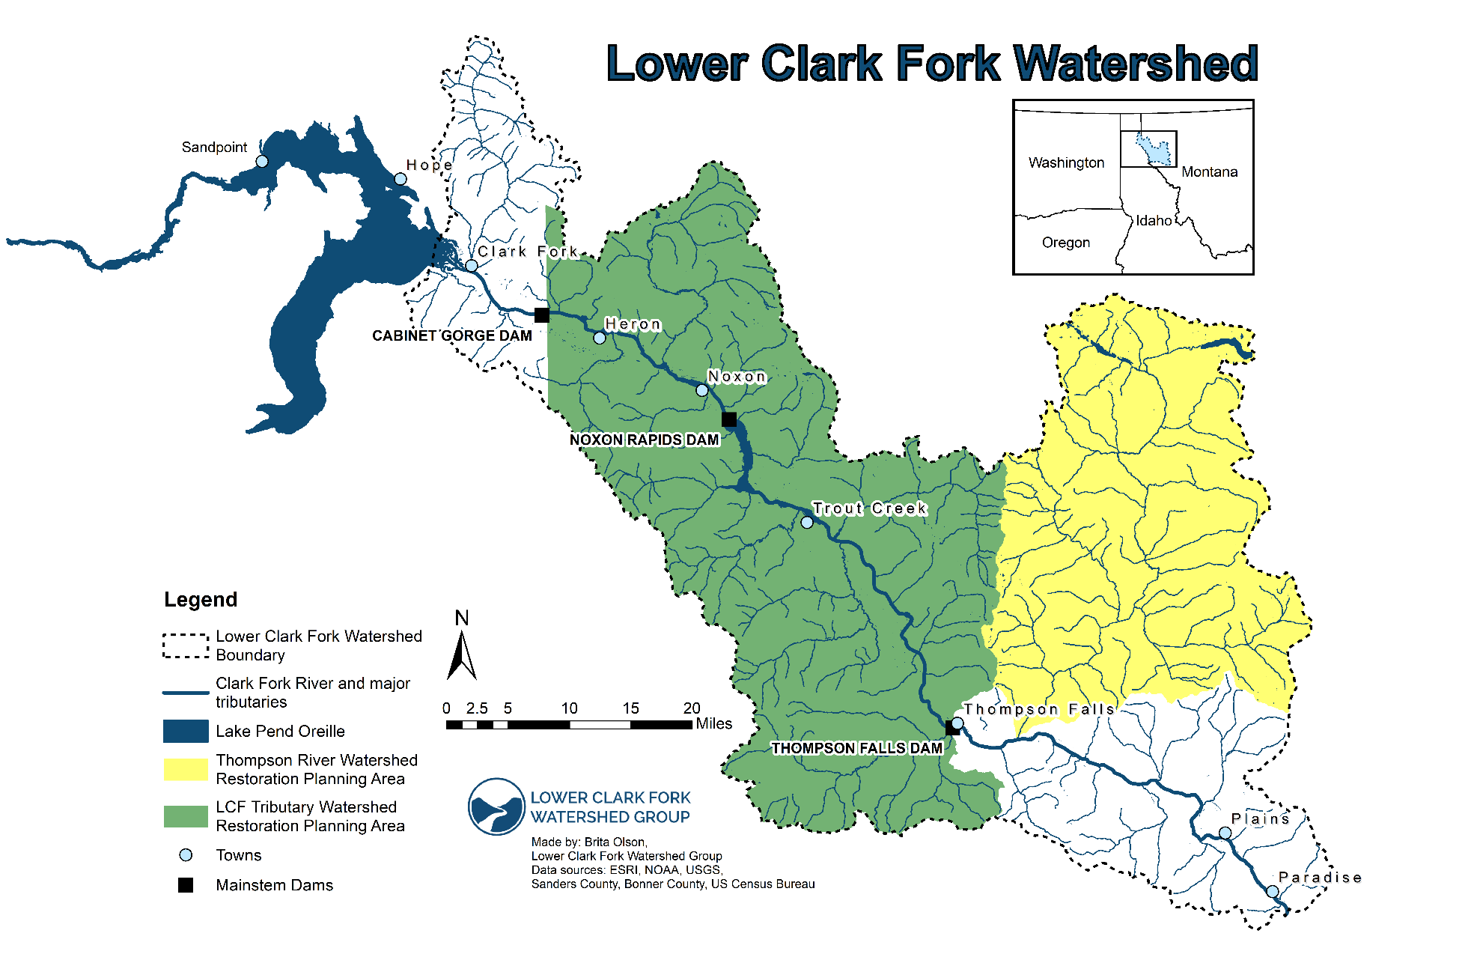
Figure 1.5A. LCF watershed restoration plan planning areas. The Thompson River Watershed Restoration Plan was completed in 2018.

The main objectives for the Lower Clark Fork Tributaries WRP are:

- To facilitate TMDL implementation and address NPS pollution of DEQ-listed impaired streams throughout the LCF watershed.
- To identify and prioritize opportunities for the protection and enhancement of additional streams that, while not listed as impaired by DEQ, are also a focus for local restoration needs and multi-faceted conservation efforts.
- To establish a DEQ-accepted WRP that can be used to receive CWA Section 319 funding, as well as to identify and to qualify for other sources of funding offered at local, state, and national levels.
- To serve as a comprehensive strategic plan for restoration in the LCF watershed to promote water quality, native fish populations, and overall ecological health.

The initial version of the Lower Clark Fork Tributaries WRP was completed in 2010 and this document is meant to serve as an update to the original plan. This document will reflect current stakeholder priorities, updated expectations for WRP documents, and will summarize progress completed since the 2010 version. This WRP will continue to be a living document that will be revised collaboratively every 10 years (or earlier if deemed necessary) and revisited annually to provide updates on project implementation progress. It serves as a user-friendly reflection of the priorities of current stakeholders and currently available information and expertise, with the understanding that there may be unforeseen events (wildfires, flooding, etc.) that change priorities and create new impetus for restoration. This plan is meant to serve as a guide for voluntary stream restoration and conservation within the LCF watershed and the suggestions made within this document are not mandated by law. This type of planning in no way overrides or undermines private property rights, water rights, or landowner preferences. By creating this plan, we will have a guide to identify and pursue voluntary stream restoration and conservation opportunities that maximize benefits to the watershed, contribute to the local restoration economy, and reflect local priorities.

The Lower Clark Fork Tributaries WRP uses a comprehensive approach to restoration in the watershed by addressing drainage systems rather than isolated stream reaches. Tributaries to impaired streams are potential contributors of NPS pollution, so restoration plans for tributary reaches will benefit the NPS reduction efforts across the watershed. Although this plan addresses drainage systems as a whole, versus isolated stream reaches, restoration planning will focus only on lotic (flowing) systems, such as streams and rivers. Lentic (non-flowing) systems, such as lakes, ponds, and reservoirs are important components of the LCF watershed, but restoration planning for these habitats is not the focus of this document. In addition, the LCF River itself is listed as impaired for temperature, dissolved gas supersaturation, fish passage barrier, and flow regime modification, all primarily caused by the hydrologic dams located on the river (DEQ 2016). While this WRP will be focusing only on tributaries to the LCF River, restoration efforts in tributaries will benefit the mainstem LCF River in the long term.

Data sources for this WRP originate from a variety of sources, including the perspectives of the stakeholders engaged throughout the development of this plan. Much of the information related to DEQ-listed streams is derived from five separate TMDL documents, all of which establishes TMDLs for the Lower Clark Fork River Tributaries and are referenced throughout this plan. Additional information is derived from a multitude of other reports and assessments that have been completed for many smaller drainages within the LCF watershed that are periodically referenced herein. Additional references will be utilized to further refine, plan, and prioritize restoration efforts through future revisions and collaboration.

