2.3: Blue Creek Watershed

Watershed Characterization
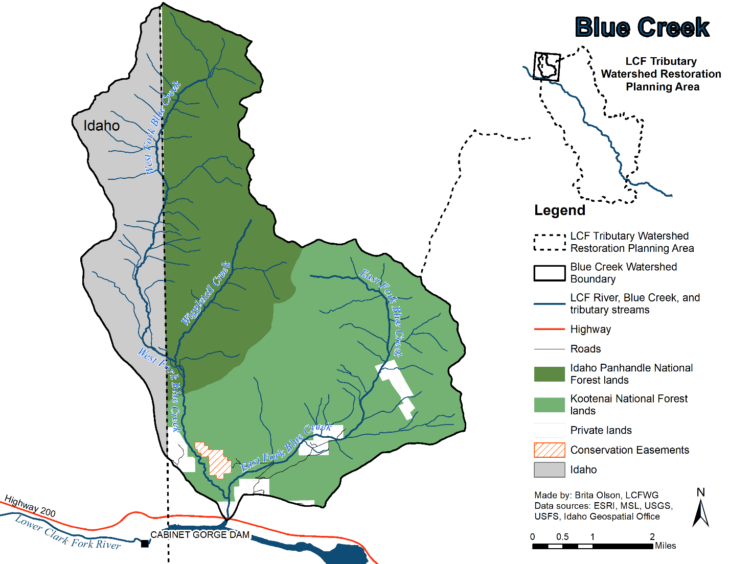
Figure 2.3A. Blue Creek watershed

The Blue Creek watershed is bounded by the Cabinet Mountain Range and encompasses approximately 30 square miles (77.7 square miles), making it one of the smallest tributary watersheds to the LCF River. The mainstem Blue Creek flows in a southerly direction before its confluence with the LCF River within the Cabinet Gorge Reservoir (Figure 2.3A). The watershed remains lightly populated with most residences located in the lower watershed near Highway 200, and the confluence of Blue Creek and Cabinet Gorge Reservoir. The USFS is the primary land manager of the Blue Creek watershed, with privately owned land making up only 5.7% of the watershed (RDG 2008) (Figure 2.3A). It is located on the Montana/Idaho border; therefore, USFS jurisdiction is split between the Kootenai National Forest (USFS-KNF) and the Idaho Panhandle National Forest (USFS-IPNF).

The Blue Creek watershed consists of two primary forks, the East Fork Blue Creek and West Fork Blue Creek (Figure 2.3A). The two forks enter Blue Creek Bay of Cabinet Gorge Reservoir in separate adjacent channels. Sediment deposition at that mouth of the West Fork Blue Creek associated with a large 2006 rain-on-snow event is such that the previous configuration of a short segment of common channel is no longer present (Moran and Storaasli 2018). West Fork Blue Creek hugs the Montana/Idaho border, crossing between the states twice before it’s confluence with Cabinet Gorge Reservoir (Figure 2.3A). The majority of West Fork Blue Creek is managed between two USFS forests, the USFS-KNF and the IPNF. East Fork Blue Creek lies entirely in Montana and is primarily managed by the USFS-KNF with inclusions of private land in the lower portion of the subwatershed (RDG 2008) (Figure 2.3A).

Riparian vegetation within the Blue Creek watershed consists of a mixture of Western Red Cedar, Western Hemlock, Spruce, Grand Fir, and Douglas Fir habitat types in various stages of succession. The dominant tree species in climax riparian forests are Western Red Cedar and Engelmann Spruce. Riparian forests are present and functioning throughout most of the watershed, but due to the historical removal of large trees via timber harvesting in the middle reaches of East Fork Blue Creek large downed wood is lacking in this area (RDG 2008).

Westslope Cutthroat Trout dominate the fish community, with a limited number of Brown Trout captured in downstream areas of both forks. No Bull Trout have been documented within the Blue Creek watershed; however, conditions exist that could facilitate occasional use by individual Bull Trout (Moran and Storaasli 2018).

Current Stream Conditions

No streams within the Blue Creek watershed are currently listed by DEQ as impaired; however, native Westslope Cutthroat Trout are the dominant fish species in East Fork Blue Creek and the only fish species that inhabits a perennial reach upstream of two perched culverts at RM 1.1 (RKM 1.7) under FSR 2745 (GEI 2005; Moran and Storaasli 2018). Therefore, East Fork Blue Creek was identified in the Lower Clark Fork River Drainage Habitat Problem Assessment (GEI 2005) as a focus area to protect and restore Westslope Cutthroat Trout habitat and continues to be a priority to stakeholders today.

Historic land uses within the Blue Creek watershed included timber harvest, hard rock mining, and recreation. Current land uses in the watershed include timber harvest, residential development, gravel extraction, and recreation. Signs of historical and relatively recent riparian timber harvest are common along many streams in the Blue Creek watershed. Large streamside cedars were harvested in the early to mid-1900s for building materials and a cedar shingle manufacturing facility was located in the Blue Creek watershed in the 1920s. While most of the stream corridor has recovered from historical timber harvests and large fires, several areas continue to exhibit the resulting impacts. Timber harvest activities no longer appear to be the dominant land impact, but there is some evidence of continued timber harvest impacts in the late 1900s. Timber harvest in East Fork Blue Creek was concentrated between the 1960s and 1980s, although riparian timber harvesting continued into the early 2000’s on private property, resulting in increased bank instability. Typical indicators of continued disturbance include stream instability, low frequency of stable LWD, and diminished riparian vegetation diversity (RDG 2008).

Most of the Blue Creek watershed remains roadless, although there are 27.5 miles (44.3 km) of road, mainly in the East Fork Blue Creek watershed. These roads were built to access logging sites and private land and are generally confined to the lower portions of the subwatershed. Road surface rilling has degraded forest roads paralleling East Fork Blue Creek in some places, contributing fine sediment to the channel where surface flows re-enter the stream. Additional sources of sediment in East Fork Blue Creek include incised high vertical banks, loss of access to adjacent floodplain areas due to channel degradation, and eroding Glacial Lake Missoula terraces (RDG 2008).

There are two culverts located on East Fork Blue Creek at the West Fork Blue Creek Road (FSR 2745) crossing that have become fish passage barriers, preventing fish movement from into upper East Fork Blue Creek. Although these culverts have eliminated the potential access to native salmonids in the LCF River, they have also excluded non-native fish species such as Rainbow Trout, Brown Trout, and Brook Trout (RDG 2008). Although isolated from downstream sources of potential hybridization, genetic sampling indicated a small percentage of Rainbow Trout introgression in a Westslope Cutthroat Trout sample taken from just upstream of these culverts, likely due to a past unauthorized introduction of Rainbow Trout in nearby sub-impoundments (Moran and Storaasli 2018). Additionally, an intermittent channel exists from RM 1.7 to 3.8 (RKM 2.7 to 6.1) and limits the amount of habitat available to Westslope Cutthroat Trout in the East Fork Blue Creek, while another intermittent reach in the lower-to-middle reaches of the West Fork Blue Creek acts similarly (Moran and Storaasli 2018). Regardless of intermittency and a limited instance of hybridization, past and recent sampling has indicated Westslope Cutthroat Trout abundances that are well above those typically observed for this species in the LCF watershed (Kreiner and Tholl 2014, Moran and Storaasli 2018). The potential of the West Fork Blue Creek to contribute to ongoing native salmonid enhancement efforts was evidenced by the tracking of individual adult Westslope Cutthroat Trout to the lower perennially-flowing area following their transport upstream of Cabinet Gorge Dam (Bernall and Johnson 2016 and in prep.).

Mining has also occurred at several locations within the Blue Creek watershed, and the largest mine (known as the Scotchman Mine) was located on private land within the East Fork Blue Creek subwatershed. A resident of Heron, MT has, for conservation purposes, purchased five of six of the uppermost private parcels along East Fork Blue Creek and has first right of refusal on the remaining parcel. This will help prevent future mining development and impacts in the area.

Natural disturbances including high magnitude fires, rain-on-snow events, and floods have also impacted the Blue Creek watershed. Historic forest fires have likely had greater impacts on East Fork Blue Creek than logging. Fires from the late 1800s and early 20th century burned large sections of the watershed, resulting in uneven-aged forest stands. Rain-on-snow events and ensuing floods have shaped the valley floor, influencing the stream corridor and local vegetation communities. The entire subwatershed burned prior to 1910 with a stand replacement fires and around 40% of the subwatershed was burned with stand replacement fires during the 1910 fires and these areas are most likely still experiencing legacy impacts from these fires (GEI 2005).

The West Fork Blue Creek subwatershed has likewise been impacted by fires, anthropogenic activities, and also other natural disturbances such as intense flooding. Fires burned the lower half of the subwatershed in 1910 and 1917. There are two FSR roads that are closed to public motor vehicle access that are not currently affecting the creek. However, some sediment still likely makes its way to West Fork Blue Creek through freeze-thaw processes, stream erosion of slope bases, and seasonal flooding which contributes to terrace failures, contributing sediment to the stream network (RDG 2008).

One of the most influential flooding events in recent history occurred in 2006 when a large storm cell created a significant flood, which radically altered West Fork Blue Creek. This estimated 400-year event resulted in large debris flows, landform failures, and bank and terrace erosion delivered large volumes of coarse sediment and LWD into the stream network (RDG 2008). The valley bottom floodplain was modified by the high flows and sediment delivery from adjacent hillslope failures. As a result of the impacts of this flood, much of West Fork Blue Creek is now in a dynamic state where the coarse sediment supply exceeds the sediment transport capacity of the system, resulting in aggraded channel conditions and potentially influencing channel dewatering due to the perched nature of the channel profile. Due to this inherent instability, restorative actions were not recommended for the West Fork Blue Creek in the Blue Creek Watershed Assessment and Restoration Prioritization Plan (RDG 2008).

Completed Projects for NPS Pollution Reduction and Native Fish Conservation (Horn 2011)

Project description | Cost | Date completed
Scotchman Mine Tailings Cleanup / Upper Kirkman Ford | $556,500+ | 2010

Planned and Proposed Projects for NPS Pollution Reduction and Native Fish Conservation

Project description | Lead Entity | Related Documents
Eroding lacustrine hillslope, East Fork Blue Creek Reach 2 |  | Blue Creek Watershed Assessment
Lower Kirkman ford, East Fork Blue Creek Reach 2 | Kootenai National Forest | Blue Creek Watershed Assessment
West Fork Blue Creek Road crossing, East Fork Blue Creek Reach 1 |  | Blue Creek Watershed Assessment

