2.6: Graves Creek Watershed

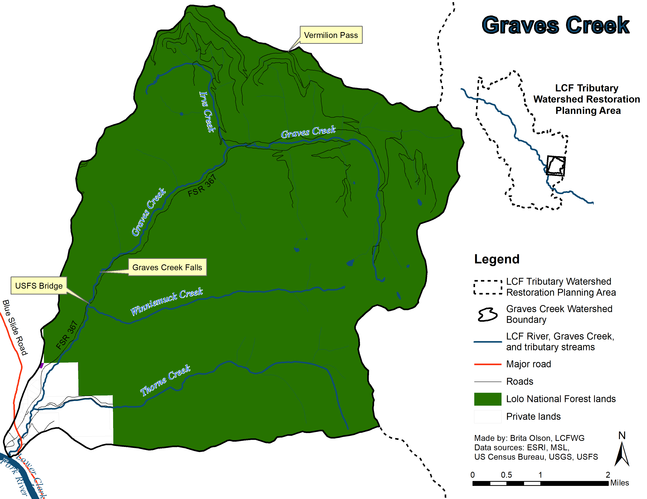
Watershed Characterization
Figure 2.6A. Graves Creek Watershed.

The Graves Creek watershed drains an area of approximately 29 square miles (75 square km) and flows approximately 13 miles (21 km) from its headwaters near Vermilion Peak and Mount Headley southwest to its confluence with the Noxon Reservoir reach of the LCF River (GEI 2005; RDG 2005; DEQ 2010). This watershed is located on the western face of the Cabinet Mountains and is separated into the upper, steeper watershed and the lower watershed by Graves Creek Falls located about 3.2 miles (5.1 km) from the river mouth (GEI 2005). There are three main tributaries to Graves Creek: Thorne Creek and Winniemuck Creek which flow into Graves Creek below the falls, and Irvs Creek which flows into Graves Creek above the falls (Figure 2.6A) (GEI 2005; RDG 2005; DEQ 2010).

The Graves Creek watershed is predominantly public land (95%), with the USFS-LNF as the primary administrators. Private ownership makes up the last 5% (including private homes and property owned by Avista Corporation) and are primarily located in the lower Graves Creek watershed along terraces adjacent to the Graves Creek floodplain and around the mouth of Thorne Creek (Figure 2.6A) (DEQ 2010; RDG 2005).
During low water years, Graves Creek experiences intermittent flows in the lower watershed from just downstream of the mouth of Thorne Creek to Noxon Reservoir. The reduced streamflow of this hydrologically losing reach can freeze solid in the winter and remain dry after the spring thaw until streamflow resumes in response to spring precipitation or low elevation run-off (Moran and Storaasli 2017). The lower watershed is also influenced by remnant beaver dams that create off-channel spring and surface water-fed habitats in reaches with wider floodplains. Relic beaver dams influence LWD distributions, floodplain morphology, floodwater and fine sediment retention, and formation of alternative aquatic habitats (RDG 2005).

The riparian forest community in the Graves Creek watershed was most likely dominated by a spruce overstory and a Rocky Mountain Maple understory prior to logging activities. Currently, the overstory is dominated by several species, including Engelmann Spruce, Black Cottonwood, Sitka Spruce, and Thin Leaf Alder, while the understory is dominated by Red Osier Dogwood, alder, hawthorn, willow, and snowberry (GEI 2005).

Native fish species present in the Graves Creek watershed include Bull Trout, Westslope Cutthroat Trout, and Mountain Whitefish and nonnative species include Brown Trout, Brook Trout, and Rainbow Trout (Moran 2003; Kreiner and Tholl 2014; Blakney 2016; Moran and Storaasli 2017). Rainbow x Westslope Cutthroat Trout hybrids are also present in the watershed below the falls (GEI 2005; Tholl and Kreiner 2012). Graves Creek is a particularly important stream for local migratory Bull Trout conservation efforts, including juvenile trapping and downstream transport and upstream transport of adults captured below Cabinet Gorge Dam (Oldenburg 2017, Bernall and Duffy 2017), and has been identified as Critical Bull Trout Habitat. To date these efforts have shown a sizable contribution to the migratory Bull Trout population and contributed to record redd counts observed in 2017 (DeHaan and Bernall 2013; Storaasli 2018). The highest densities of Bull Trout occur from the USFS boundary upstream to the falls, and low densities of Bull Trout have also been recorded in lower Thorne Creek (Moran and Storaasli 2017). Graves Creek Falls acts as a natural barrier dividing the salmonid populations into two distinct reaches. Below the falls Westslope Cutthroat Trout and adfluvial Bull Trout are the dominate populations, while Brook Trout and Westslope Cutthroat Trout dominate the populations above the falls (Moran 2002; Blakney 2016; Moran and Storaasli 2017).

Current Stream Conditions

Graves Creek has been listed by DEQ as impaired for alteration in stream-side or littoral vegetative cover, which affects aquatic life and cold water fishery uses (DEQ 2010). Land use is fairly limited and USFS-LNF’s management activities have an over-riding influence on the watershed. Primary land uses that have impacted the stream include historic timber harvest activities, historic and existing roads, and private land use including logging, site clearing, and home development (RDG 2005).

Timber harvest activities have been limited to the headwaters of Graves Creek, the valley bottom reaches of mainstem Graves Creek, and much of the Irvs Creek subwatershed. Additional timber harvest has occurred on the private land toward the mouth of Thorne Creek, although the extent of activity has not been quantified. A total of 14% of the Graves Creek watershed was harvested between 1957 and 1981. Approximately 993 acres (78%) of the Irvs Creek subwatershed was harvested in the 1960s and it continues to recover from these past harvests. Although most of the harvested area is now revegetated, some erosional gullies have formed. However, vegetation buffers appear to be protecting the stream network from fine sediment delivery originating on upper slopes (RDG 2005).

Approximately 20 miles (32.2 km) of road are located in the headwaters of Graves Creek, including a system of roads east of the Irvs Creek subwatershed. The roads were built to provide access to the harvest units in the headwaters, as well as access to Vermilion Pass. Though many of these roads are now closed to motorized traffic and are partially revegetated, they continue to alter hydrologic connectivity on upland slopes. Culverts on the active road system are in place, but are generally undersized. One culvert on FSR 367 approximately 1 mile (1.6 km) upstream of the Irvs Creek confluence acts as a partial fish passage barrier. Approximately 3 miles (4.8 km) of road in Lower Graves Creek are privately owned and managed, and the length of private road in this area is expected to increase as private parcels are subdivided and developed (RDG 2005). There are approximately 2 miles (3.2 km) of road located along the lower 1.5 miles (2.4 km) of Thorne Creek below the USFS boundary. Privately owned and managed roads 60043 and 60044 also parallel Thorne Creek for approximately 0.75 miles (1.2 km) below the USFS boundary. No roads exist on federal land beyond the USFS-Private boundary in the Thorne Creek subwatershed. The road network in Winniemuck Creek is limited to a foot trail on the northern side of the creek which is fairly distant from the creek on terraces and middle to upper slopes (RDG 2005).

While Graves Creek is not currently listed as impaired by sediment, there are a few concerning areas of potential sediment sources to Graves Creek throughout the watershed. Sediment in this watershed typically comes from four categories, including slope failure (mass wastes), avalanche, eroding terrace/bank, and talus fields. Sediment sources in the headwaters of Graves Creek are limited and are primarily related to mass wastes, channel widening, and bank instability. A natural talus field is also located in the upper portion of the headwaters that causes moderate channel divergence and contributes large material to the channel. Riparian spruce harvest in this area between 1957 and 1967 removed large diameter trees, reducing bank protection and stability. Between Graves Creek Falls and the USFS boundary, there are extensive sediment delivery sources related to glacial moraine terraces and glacial Lake Missoula deposits. These sources are delivering sediment directly to the stream because the narrow floodplain provides little buffer for incoming sediment. Also in this section, Graves Creek Road crosses the stream near the Winniemuck Creek confluence and encroaches again on Graves Creek approximately a quarter mile downstream of the crossing. This road is delivering sediment to Graves Creek during rain events and spring runoff, and is a dust source during dry summer months. Between the USFS boundary and Graves Creek’s confluence with Noxon Reservoir, mass wastes and widening channels again are the primary contributor of sediments. Vegetation along the stream in this section is typically poor, which also indicates that stream shading is minimal (RDG 2005).

Within the Thorne Creek subwatershed, private road building and timber harvest are the primary sources of sediment. Several road prisms have failed within this subwatershed, delivering sediment directly into the stream and providing a source of fine sediment that impacts aquatic habitat and the suitability of the creek as spawning and rearing areas for Bull Trout (GEI 2005). The forest has been thinned from the mouth of Thorne Creek upstream to the USFS boundary on the eastern half, but the majority of the road network and harvest areas exist on the northern hillside and most sediment sources are limited to the privately owned reach near the confluence of Thorne Creek. Non-motorized trail construction and maintenance appear to be the only current management within the USFS portion of this subwatershed, and has occurred primarily in upland areas (RDG 2005).

There are currently no management-related sediment sources within the Winniemuck Creek subwatershed; however, the forest is interrupted by an extensive natural talus field located on the northern hillslope which consists of coarse hillslope debris and lacks vegetation or any soil development. Entry of sediment materials in this area is naturally derived via avalanche and mass wasting. The Irvs Creek subwatershed is similar in that there are no major management-related sediment sources, but a natural talus slope in the upper Irvs Creek subwatershed may be contributing coarse materials to the stream (RDG 2005).

Overall, Graves Creek maintains cool water temperatures and contains adequate fish habitat; although pool frequency and LWD has been characterized as less common than other area tributaries, particularly for areas downstream of Graves Creek Falls (WWP 1996, RDG 2005). Steeper step-pool reaches maintain deep scour pools and these areas are typically well shaded. Floodplain riparian vegetation contributes LWD to the stream and also increases bank stability. Areas with well-vegetated floodplain provides stream shading, bank stability, and floodplain roughness for slowing overbank flows during peak discharge events. Salmonid spawning and rearing habitat in the lower Graves Creek watershed are believed to be limited by the infrequent distribution of LWD, distribution of spawning gravels, and potentially, seasonal channel dewatering in the lower reach. The primary Bull Trout spawning area is located in the 2,500 ft downstream from Graves Creek Falls and is adjacent to a large natural sediment source. The concentration of the majority of the spawning Bull Trout in this one area increases the susceptibility of the adult spawners to predators and poachers, and redds in this area are at risk of natural events such as an intense rainstorm or early season rain on snow event that could create scouring flow that negatively impacts egg and embryo survival.

Thorne Creek provides sufficient aquatic habitat to maintain a population of small Westslope Cutthroat Trout, while the occasional sampling of lower Thorne Creek has also recorded a small number of Bull Trout (Moran and Storaasli 2017). Deeper and more frequent complex pools near the confluence may account for the greater number of Westslope Cutthroat Trout in the downstream portion of the watershed and the abundance and size of Westslope Cutthroat Trout generally decrease upstream. Winniemuck Creek is isolated from Graves Creek during base flows when the confluence becomes intermittent. A high gradient cascade upstream from the mouth of Winniemuck Creek may also be a barrier to fish passage for fish attempting to immigrate to Winniemuck Creek. Irvs Creek has a steep channel profile and limited fish habitat. However, the well-shaded and step-pool morphology maintains cold water discharge to Graves Creek (RDG 2005).

Completed Projects for NPS Pollution Reduction and Native Fish Conservation (Horn 2011)

Project description | Cost | Date completed
Graves Creek Restoration (Cox/Newby) | $72,230 | 2009
Graves Creek Trap Site Improvement (Avista) | $17,600 | 2007
Thorne Creek Fish Passage Barrier (Cox)
Avista Land Acquisition for fish conservation (Lower Graves Creek)
Avista permanent weir facility for fish conservation

Planned and proposed projects for NPS Pollution Reduction and Native Fish Conservation

Project description | Lead Entities | Related documents
Graves Creek Pilot LWD Enhancement | USFS-LNF, FWP, LCFWG, TU, Avista | 2018 CFSA Annual Implementation Plans
Large Woody Debris placement |  | Graves Creek Watershed Assessment (2004)
Reach 4-2 Braided section (Miller and Swing Trustees, Cox) |  | Graves Creek Watershed Assessment (2004)
Reach 4-2 Eroding glacial/lacustrine terrace (Cox) |  | Graves Creek Watershed Assessment (2004)
Thorne Creek sediment source (Cox)
Blue Slide Road culvert crossing undersized |  | Personal communication, Jon Hanson
LWD additions in lower Graves for Bull Trout spawning | USFS-LNF, FWP, LCFWG, TU, Avista | Personal communication, Jon Hanson
Work with landowners in lower section on water rights |  | Personal communication, Jon Hanson
Complete a roads assessment in watershed | USFS-LNF | Personal communication, Jon Hanson
Conservation easement / land purchases?

