2.7: Marten Creek Watershed

Watershed Characterization
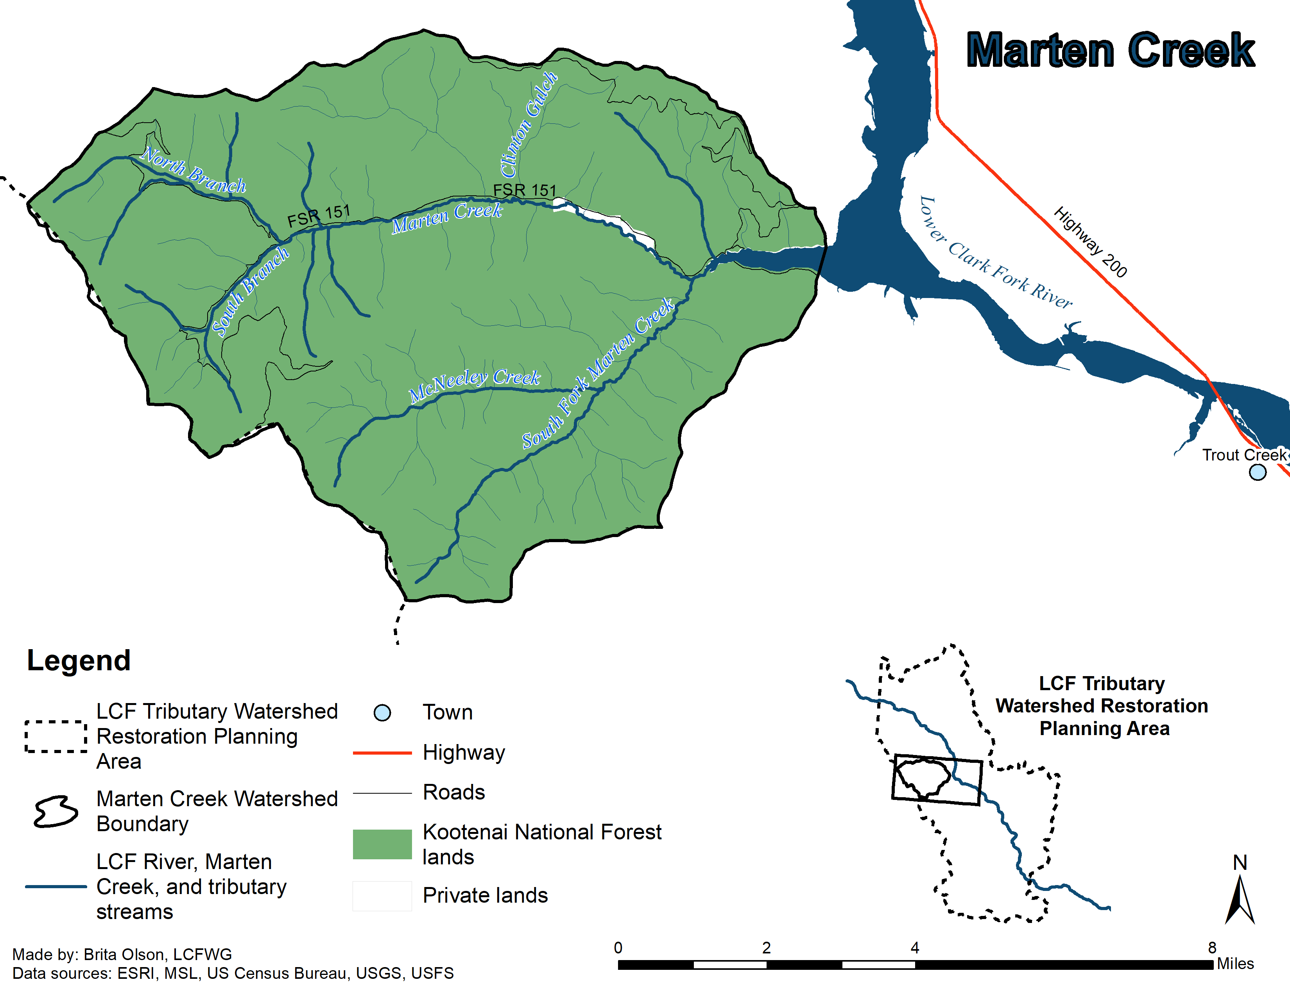
Figure 2.7A. Marten Creek Watershed.

The Marten Creek watershed drains an area of approximately 46 square miles (119 square km) (DEQ 2010) of the Coeur d’Alene Range. Mainstem Marten Creek flows east for approximately 8.5 miles (14 km) from the confluence of the South and North branches to its confluence with Noxon Reservoir of the LCF River. The watershed is predominantly public land (99.5%), with the USFS-KNF as the primary land manager, with the remaining under private ownership (0.5%) (Figure 2.7A) (GEI 2005).

Both the mainstem and the South Fork of Marten Creek are characterized by numerous beaver dams and side channels in their lower reaches, and extensive areas that are seasonally intermittent in their middle reaches. Mainstem Marten Creek exhibits intermittency from Clinton Gulch upstream to near the confluence of North and South branches. South Fork Marten Creek also has an extensive area of seasonally dry channel that typically extends from approximately 0.3 miles (0.5 km) upstream of its confluence with Marten Creek to the vicinity of McNeeley Creek (GEI 2005).

Fisheries monitoring of the drainage has been limited and consisted of electrofishing, genetic sampling, and nearly annual Bull Trout and Brown Trout redd surveys (WWP 1996, GEI 2005, Moran and Storaasli 2015, Storaasli 2018). These efforts record a salmonid community dominated by non-native species in the lower reaches, with a pure Westslope Cutthroat Trout populations in the upper areas of the drainage. The Marten Creek drainage does not currently support a Bull Trout population; although periodic use of downstream areas for limited Bull Trout spawning (Storaasli 2015) and one instance of juvenile straying have been documented (Moran and Storaasli 2015). This limited and sporadic use by Bull Trout is likely influenced by the perennial lower reaches of the mainstem Marten and South Fork Marten creeks being in close proximity to the deepwater habitat of the Marten Creek Bay. These lower reaches may represent a “last resort” spawning area for Bull Trout entrained in Noxon Reservoir that are unable to reach their natal tributaries. Assessment of Bull Trout historically inhabiting this drainage was based on anecdotal accounts (Pratt and Huston 1993); however, no Bull Trout were captured during widespread sampling of the drainage in the 1990s (WWP1996).

Current Stream Conditions

Marten Creek is listed as impaired by sediment and for the non-pollutant ‘physical substrate habitat alterations’ by DEQ which are impairing aquatic life and coldwater fisheries (DEQ 2010). Native fish populations within the Marten Creek watershed are impaired by a variety of factors including sediment loading, stream intermittency, fish passage barriers, low amounts of LWD, and suitable spawning and rearing habitat, and a dominance of non-native species in downstream areas (GEI 2005; DEQ 2010, Moran and Storaasli 2015).

During normal years, stream flows support fish in the mainstem between the mouth and RM 3.2 (RKM 5.2) and between RM 5.4 (RKM 8.7) and RM 8 (RKM 12.9). The stream has moderate amounts of LWD, with generally more LWD in mainstem Marten Creek upstream of the confluence with Fir Creek than downstream (GEI 2005). Flooding events in 2008 have resulted in bank cutting, hillslide mass wasting, terrace erosion, lateral channel migration, channel widening and subsequent channel braiding in a number of areas along mainstem Marten Creek (Neesvig 2009a).

Road development and land use have influenced the stability of mainstem Marten Creek. FSR Road 151 follows mainstem Marten Creek within 100 m of the channel for much of its length, in addition to the roads found in the riparian zone of both North and South branches. This road development has been associated with increased sediment loading, surface runoff, erosion, and decreasing the bank stability and stream cover (GEI 2005; Neesvig 2009a). Private lands are located along the mainstem Marten Creek downstream of Clinton Gulch along the principal area of the channel with perennial streamflow (GEI 2005). Land use on private lands historically included riparian harvest during the early 1900s through the 1960s, resulting in accelerated lateral migration of the stream from vegetation removal. Some of the major sediment contributing areas within the Marten Creek watershed have previously been found along private lands due to mass wasting and historic land use practices. Conditions in this area have improved; however, fisheries sampling indicated that non-native species dominate the assemblage within this reach (Moran and Storaasli 2015).

Riparian and stream channel conditions along a majority of both lower and middle areas of these streams reflect legacy impacts of past riparian logging, as well as road and powerline development. These impacts are reflected in lower amounts of mature woody riparian vegetation and associated lower LWD counts and pool frequency compared to other tributaries to the LCF River (WWP 1996). Overall, these stream habitat deficiencies and extensive areas of seasonally intermittency have diminished the potential for large areas of the drainage to support salmonid communities.

Completed Projects for NPS Pollution Reduction and Native Fish Conservation (Horn 2011)

Project description | Cost | Date completed
Marten Creek – Smith Property: Lower Marten Creek Channel Restoration (Bank Stabilization and Riparian Revegetation) | $100,000 | 2009
Marten Creek Revegetation | $12,450 | 2009 & 2010

Planned and Proposed Projects for NPS Pollution Reduction and Native Fish Conservation

Project description | Lead Entity | Related documents

