2.9: Prospect Creek Watershed

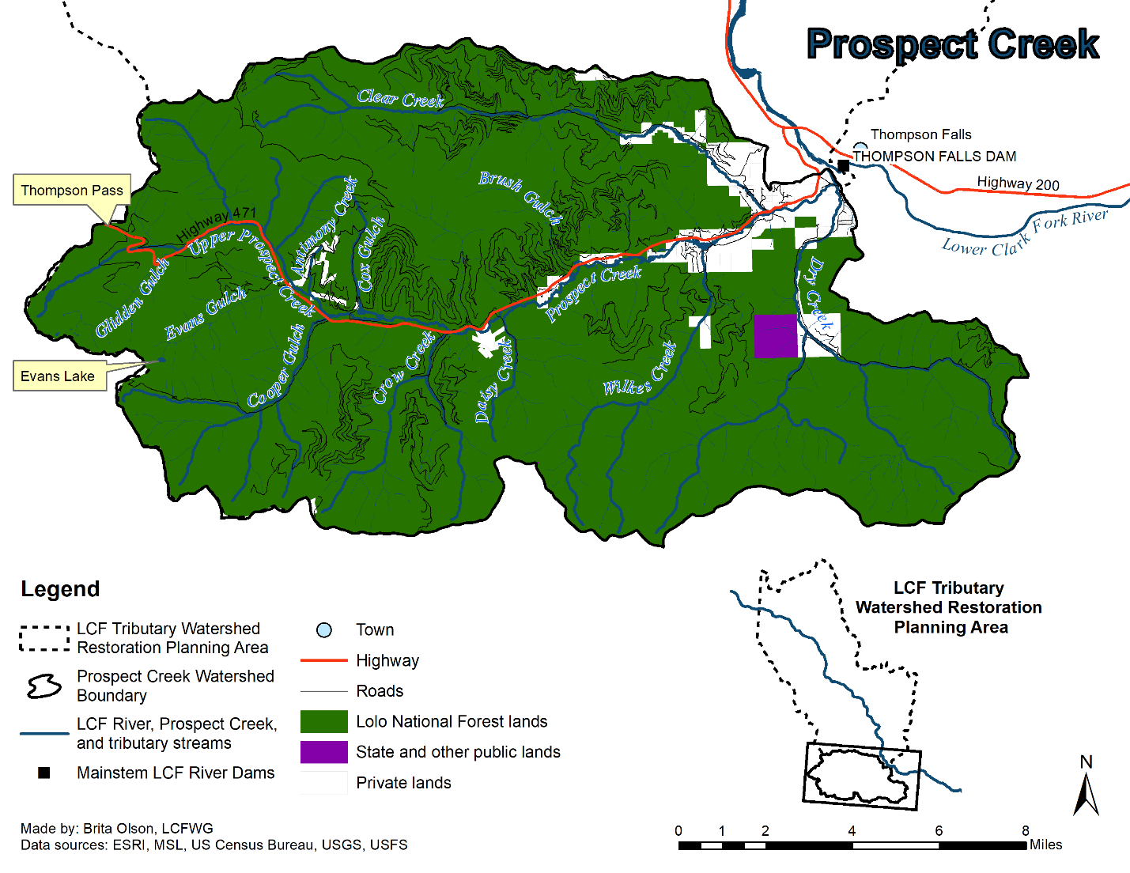
Watershed Characterization
Figure 2.9A. Prospect Creek Watershed.

The Prospect Creek watershed encompasses an area of approximately 182 square miles (471 square km) and is located on the eastern face of the Coeur d’Alene Mountains. The mainstem flows northeast approximately 19 miles (30.6 km) from its headwaters near the Montana-Idaho border to its confluence with the LCF River within the Noxon Reservoir, immediately downstream of Northwestern Energy’s Thompson Falls Dam. Primary tributaries within the Prospect Creek watershed include Clear Creek, Dry Creek, Wilkes Creek, Cooper Gulch, and Crow Creek (Figure 2.9A) (RDG and USFS LNF 2004; GEI 2005; DEQ 2006; DEQ 2009; Moran and Storaasli 2018).

The Prospect Creek watershed is predominantly public land, with USFS-LNF as the dominant land owner/manager (94%). Private lands are primarily located in the valley bottoms adjacent to the stream corridor (Figure 2.9A). There are a number of utility corridors maintained throughout the watershed, including those from the Yellowstone Pipeline (YPL), Northwestern Energy (NWE), and Bonneville Power Administration (BPA) (RDG and USFS LNF 2004; GEI 2005; DEQ 2006; DEQ 2009). The YPL pipeline was re-routed primarily along County Highway No. 471 and crosses mainstem Prospect Creek multiple times. The NWE utility corridor follows a similar route as the YPL until the confluence of Cooper Gulch, where it veers south and parallels mainstem Cooper Gulch upstream to the watershed divide. The BPA powerline follows mainstem Prospect Creek and diverges to follow Crow Creek upstream (GEI 2005).

Road construction began in the Prospect Creek watershed around the beginning of the 20th century and is generally limited to the middle to lower reaches of the watershed. The primary roadway through the watershed is County Highway No. 47, which runs through the entirety of the Prospect Creek watershed beginning near the confluence of Prospect Creek with the LCF River and continuing through to Thompson Pass at the Montana-Idaho border (Figure 2.9A) (GEI 2005).

Mainstem Prospect Creek and many of its tributaries are characterized by extensive areas that go dry during base streamflow conditions. The upper and lower sections of the mainstem are separated by large intermittent reaches (approximately 8.5 miles (13.7 km)) which go dry during base streamflow conditions each year, due to the porous nature of the valley alluvium which in large part is comprised of coarse unconsolidated Glacial Lake Missoula derived sediments (Sando and Blasch 2015). This condition has been exacerbated by channel widening, increasing the channel areas exposed to infiltrative streamflow losses. Stream intermittency was also exacerbated by sediment deposition resulting from the fires of 1889 and 1910 and the large magnitude floods that followed in 1916 (RDG and USFS LNF 2004; DEQ 2006; DEQ 2009; Kreiner and Tholl 2014; Moran and Storaasli 2018).

Historic dominant riparian vegetation types within the Prospect Creek watershed included Western Red Cedar/ Lady Fern (located on drier sites) and/or Western Red Cedar/Devil’s Club (located on wetter sites) habitat types. Additional riparian vegetation species include Black Cottonwood, alder, and birch for overstory species, and Red Osier Dogwood, alder, hawthorne, willow, and snowberry for understory species. While some areas within the watershed have experienced cedar recolonization, many reaches are now populated by Douglas Fir and spruce. Introduced vegetation species, such as Reed Canarygrass are also currently present in the watershed in multiple areas (RDG and USFS LNF 2004; DEQ 2006; DEQ 2009).

The fish community of the Prospect Creek watershed is made up of native Bull Trout and Westslope Cutthroat Trout and non-native Brook Trout, Brown Trout, and Rainbow Trout. The Prospect Creek watershed is considered core spawning and rearing habitat for Bull Trout (DEQ 2009). Accounts indicate that Bull Trout, particularly the migratory life form, were previously much more abundant in the Prospect Creek watershed (Pratt and Huston 1993). Since the construction of Cabinet Gorge, Noxon Rapids, and Thompson Falls dams, the LCF River no longer represents an open system for migratory Bull Trout maturing in Lake Pend Oreille. Most migratory Bull Trout utilizing Prospect Creek today likely spend their adult rearing state in Noxon Reservoir.

Bull trout redd surveys, fish trapping and telemetry data, and life history studies all portray a limited number of migratory Bull Trout using the lower mainstem below Brush Gulch for spawning and rearing, with a resident meta-population of Bull Trout inhabiting the upper perennial mainstem and Cooper Gulch primarily, with a smaller component inhabiting the Crow Creek drainage (Zymonas 2006, Moran and Storaasli 2013 and 2018, DeHaan and Bernall 2017, Blakney in prep..). Westslope Cutthroat Trout are the most abundant fish species in upper Prospect Creek, Cooper Gulch, and Crow Creek, while non-native fish are practically non-existent from the upper watershed except for limited Brook Trout in Evans Lake and a few Rainbow Trout sampled in the short perennial section below the confluence of Crow Creek (Mroan and Storaasli 2013; Kreiner and Tholl 2014).

Brook Trout were the dominant species in the lower watershed during recent sampling, followed by Rainbow Trout and Brown Trout (Kreiner and Tholl 2014). Bull Trout and Westslope Cutthroat Trout are much less common: no more than 3 individuals of either species have been captured in any of the lower three monitoring sections located between Clear Creek and Brush Gulch in 2011 and 2013 (Kreiner and Tholl 2014). Prospect Creek enters a small canyon downstream of Clear Creek with correspondingly better instream habitat features. Limited sampling in this area still indicates that the fish community is dominated by non-native species, although remote sensing has shown it functions as a travel corridor for native species. Some isolated populations of Westslope Cutthroat Trout are found in the headwaters of tributaries to the lower watershed, such as Wilkes Creek, Clear Creek, and Dry Creek, typically protected by intermittent reaches acting as a barrier to upstream non-native salmonid invasion (Moran and Storaasli 2018).

Current Stream Conditions

The Prospect Creek watershed has been subject to both natural and anthropogenic disturbances dating back to the 19th century. The combined effects of wildfires, riparian vegetation clearing and conversion, utility corridor and gas pipeline installation and associated maintenance activities, highway encroachments, and mining activities have combined to alter and impair the mainstem corridor as well as numerous tributaries, resulting in five streams being listed by DEQ as impaired for NPS pollutants and non-pollutants. Mainstem Prospect Creek and two major tributaries, Clear Creek and Dry Creek, have all been listed as impaired by sediment and the non-pollutant alteration in streamside vegetation. Two minor tributaries to Prospect Creek, Antimony Creek and Cox Gulch, as well as mainstem Prospect Creek have been listed as impaired by metals (namely antimony, arsenic, lead, or zinc) (DEQ 2006; DEQ 2009; DEQ 2018). Generally, there are three potential sources of metals-related water quality impairments within the LCF watershed, including natural background loading, historic mining activities dating back to the late 1800s, and recent mining and metals processing activities conducted by the U.S. Antimony Corporation (DEQ 2006). Sources of metal contamination from mining activities include:
- Tailings impoundments acting as sources of metals contamination to shallow groundwater and surface water (DEQ 2006); and
- Mining ponds containing high levels of metals leaching into unconfined groundwater aquifers (RDG and USFS LNF 2004).
All of these impairments affect aquatic life and cold water fishery uses within the Prospect Creek watershed (RDG and USFS LNF 2004; DEQ 2006; DEQ 2009; DEQ 2018).

Vegetation in the Prospect Creek watershed have experienced several changes related to natural and human activities. Much of the watershed was burned in stand-replacing fires in 1880 and 1910. Logging of the LCF watershed began in the late 1800s with the removal of accessible cedars and other species useful for building materials by early homesteaders. Cedars stumps can still be observed within the Clear Creek and Wilkes Creek subwatersheds, as well as along mainstem Prospect Creek. Although some areas have experienced cedar recolonization, many riparian areas are now populated by fir, pine, spruce, cottonwood, alder, and other earlier successional-stage species. While these species can provide several of the benefits attributed to cedars, the simplified riparian vegetation communities, particularly those dominated by alder provide less channel shading, channel complexity, and bank stability than the historic cedar riparian vegetation. Displacement of native woody vegetation by introduced Reed Canarygrass has reduced bank scour resistance, fish and riparian habitat quality, and channel shading. Impacts attributed to riparian community conversion include accelerated bank erosion and sediment loading to the mainstem and its tributaries, impaired aquatic habitat, elevated stream temperatures, and channel widening (RDG and USFS LNF 2004; GEI 2005).

Roads and utility corridors act as a substantial sediment source to mainstem Prospect Creek and its tributaries, especially when they are in close proximity to the stream channel. For example, approximately 1.9 miles (3.1 km) of Highway 471 is located witin 125 ft (38 m) of mainstem Prospect Creek and approximately 5.4 miles (8.7 km) of mainstem Prospect Creek is within 125 ft (38 m) of a utility corridor. The routine maintenance of utility corridors includes removing trees from riparian forests, which reduces bank integrity and the amount of potential LWD recruitment into the stream channel (GEI 2005). Additionally, bank armoring along many of these interface areas contributes to mainstem and tributary channel dis-equilibrium and habitat simplification.

Historic and recent mining activities and natural veins are the primary source for metal pollutants within the Prospect Creek watershed. Historic mining activity is evident throughout the watershed, especially within Antimony Creek and Cox Gulch. All historic mining has been underground and focused on development of antimony ore. Mining activities started slow in the late 1800s, but production increased during both World Wars. The United States Antimony Corporation (USAC) operates an antimony mining and milling facility in the watershed near the mouth of Cox Gulch. USAC began operation in 1970 with the reopening of the Stibnite Hill underground mine and continued until 1983. They operated a furnace for production of antimony oxides from imported antimony concentrate (DEQ 2006). Previous studies (Woessner et al 1985) identified three tailings impoundments associated with the USACE operation leaching metals into shallow ground water and surface water in the vicinity of the plant at the time of the investigation (one of which has been since reclaimed). In addition to these anthropogenic sources, natural sources of Antimony, and potentially other metals, exist within the watershed. Stibnite veins occur at or near the surface throughout the Antimony Creek and Cox Gulch subwatersheds and are known conduits for ground water flow, evidenced by the presence of springs in many vein locations. Many veins are also reported to contain arsenic “blooms”, a green arsenic oxide mineral, the presence of which suggests that oxidation of the sulfide ore has occurred, which typically is accompanied by natural leaching of the metals to the environment (DEQ 2006).

Seasonal stream intermittency limits Bull Trout migration within the Prospect Creek watershed. There are two intermittent reaches located within the mid-reaches of mainstem Prospect Creek that affect the distribution of both migratory and resident Bull Trout within the watershed, as well as other native and nonnative fishes. The lower intermittent reach begins near Brush Gulch and ends upstream near the mouth of Daisy Creek. The upper intermittent reach begins near the mouth of Crow Creek and ends just upstream of Evans Gulch (GEI 2005). These intermittent reaches effectively cut the Prospect Creek watershed in half, creating an upper and lower watershed (Kreiner and Tholl 2014). Despite these imitations, the Prospect Creek watershed is still considered Critical Habitat for Bull Trout (GEI 2005).

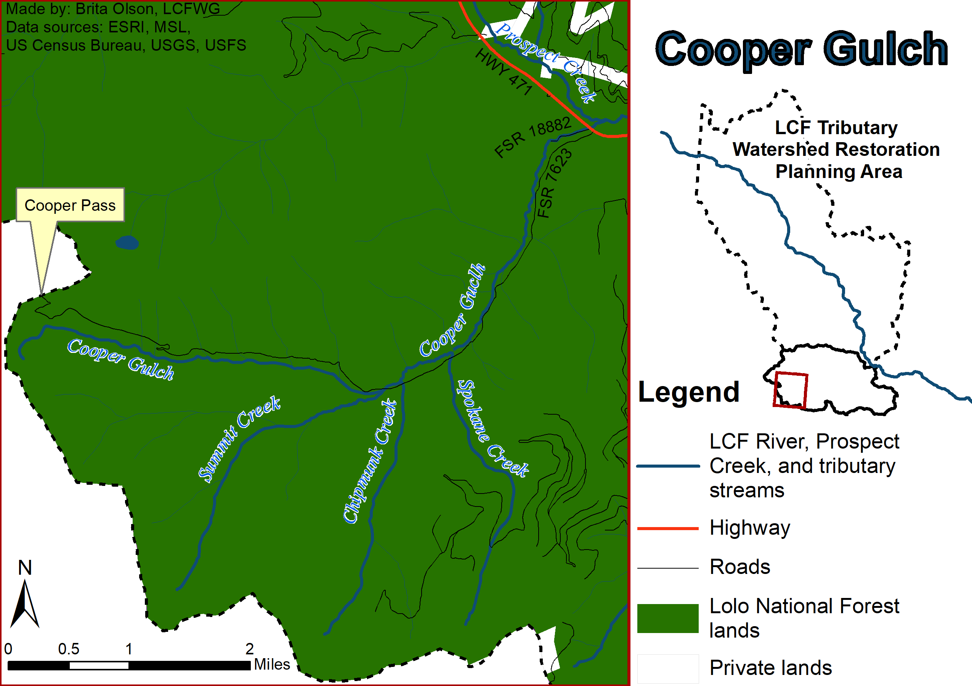
Upper Prospect Creek and its tributaries are overall in stable condition, generally have cooler summer water temperatures, and provides high quality habitat for both Bull Trout and Westslope Cutthroat Trout (Mroan and Storaasli 2013; Kreiner and Tholl 2014). Cooper Gulch (Figure 2.9B) enters upper mainstem Prospect Creek. The impacts to stream function and habitat within the Cooper Gulch subwatershed comes from road development, past forestry practices, and the presence of a Northwestern Energy powerline, which extends up the entire length of the valley bottom from County Highway No. 471 to the Montana-Idaho border at Cooper Pass. Seasonal intermittency occurs for approximately 1 mile (1.6 km) of lower Cooper Gulch and for short stretch (i.e., approximately 656 ft) located just upstream of the confluence with Spokane Creek. Historic timber harvest occurred throughout the valley bottom removing a dense cedar overstory. There is little cedar regeneration due to loss of seed source from timber harvesting and the persistent maintenance of the powerline and road corridors that removed trees from the riparian area (GEI 2005). The headwater reaches of Cooper Gulch are in overall stable condition, but from just above Summit Creek to Chipmunk Creek, the stream condition becomes unstable in places due to removal of large cedars, and the constriction of the channel due to its close proximity to the powerline and road. The area just downstream of the Chipmunk Creek is more distant from the road and powerline, promoting diverse, dense and mature riparian vegetation. The lowest 0.8 miles of Cooper Gulch above County Highway No. 471 crossing is a long, straight, entrenched riffle that is seasonally intermittent. Sediment within this subwatershed is mainly produced from in-channel sources as a result of bank instability associated with loss of riparian vegetation (GEI 2005). Despite these conditions, Cooper Gulch provides important habitat within the upper Prospect Creek drainage for Westslope Cutthroat Trout and Bull Trout (Moran and Storaasli 2013 and Kreiner and Tholl 2014).
Figure 2.9B. Cooper Gulch Subwatershed.

Crow Creek (Figure 2.9C) enters Prospect Creek at approximate RM 12.2 (RKM 19.6) and contributes streamflow that, except for historically low water years, results in a short (approximately 0.5 miles (0.8 km) long) isolated reach of middle Prospect Creek with perennial streamflow. Powerlines from BPA and NWE extend up the lower valley bottom of the mainstem from County Highway No. 471 to the confluence of the East and West Forks Crow Creek. At the confluence of the forks, the powerlines follow the ridge dividing the watersheds of the forks to the Crow Creek Divide. The Crow Creek valley bottom and lower portions of the east and west forks were historically dominated by dense cedar stands. Large cedar stumps and remnant large cedar snags are still visible on the valley floor, while live cedars still exist along both the east and west fork and just downstream where the two forks meet on mainstem Crow Creek. The riparian areas have experienced persistent loss of vegetation from timber harvest and the maintenance of roads and the powerline corridor which has led to bank instability, vegetation loss, lateral migration, increased width-to-depth ratios, increased sediment supply, lack of LWD, and reduced stream shading along much of the upper half of Crow Creek (GEI 2005; Kreiner and Tholl 2014). The lower half of Crow Creek is relatively well vegetated with dense overstory; however, the stream channel still reflects habitat deficiencies with elevated width-to-depth ratios, low entrenchment, and limited LWD. The lowest 0.5 mile (0.8 km) of Crow Creek above the Prospect Creek is confined by County Highway No. 471 and parallels a newly re-routed section of the YPL pipline. Overall road density within the Crow Creek subwatershed is high and is a primary limiting factor within the watershed alongside utility corridor. In addition to these anthropogenic impacts, low to moderate amounts of natural sediment is contributed annually to the stream, with the highest amount of natural sediment coming from the alpine glaciated valleys of the headwaters (GEI 2005).
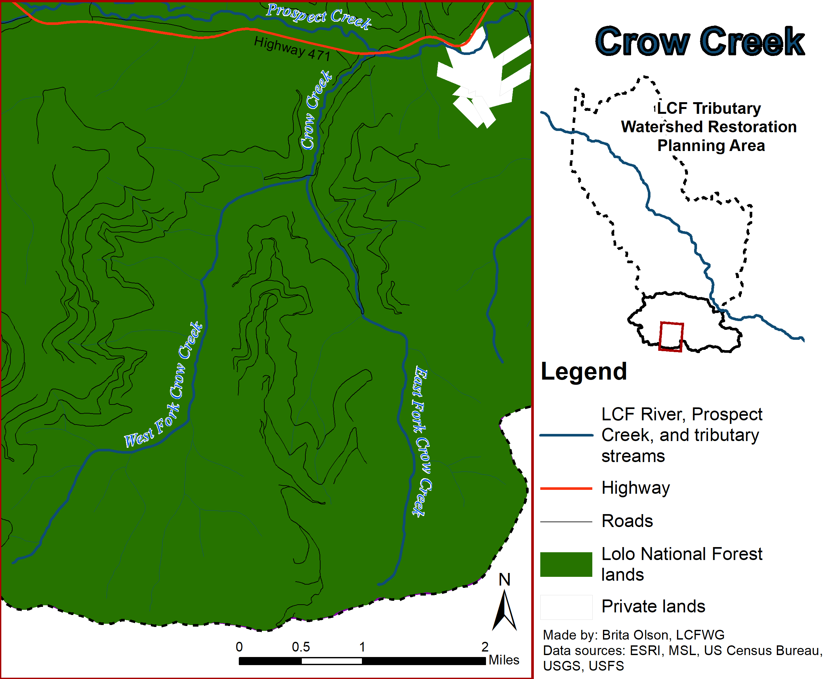
Figure 2.9C. Crow Creek Subwatershed.

Within Lower Prospect Creek, degraded habitat and increased temperatures caused by residential development, roads, historic mining, a gas pipeline, and two powerline corridors have created habitats which are more easily inhabited by non-native species with higher tolerances for degraded conditions. As a result, the lower watershed supports few native salmonids and abundant non-native species.

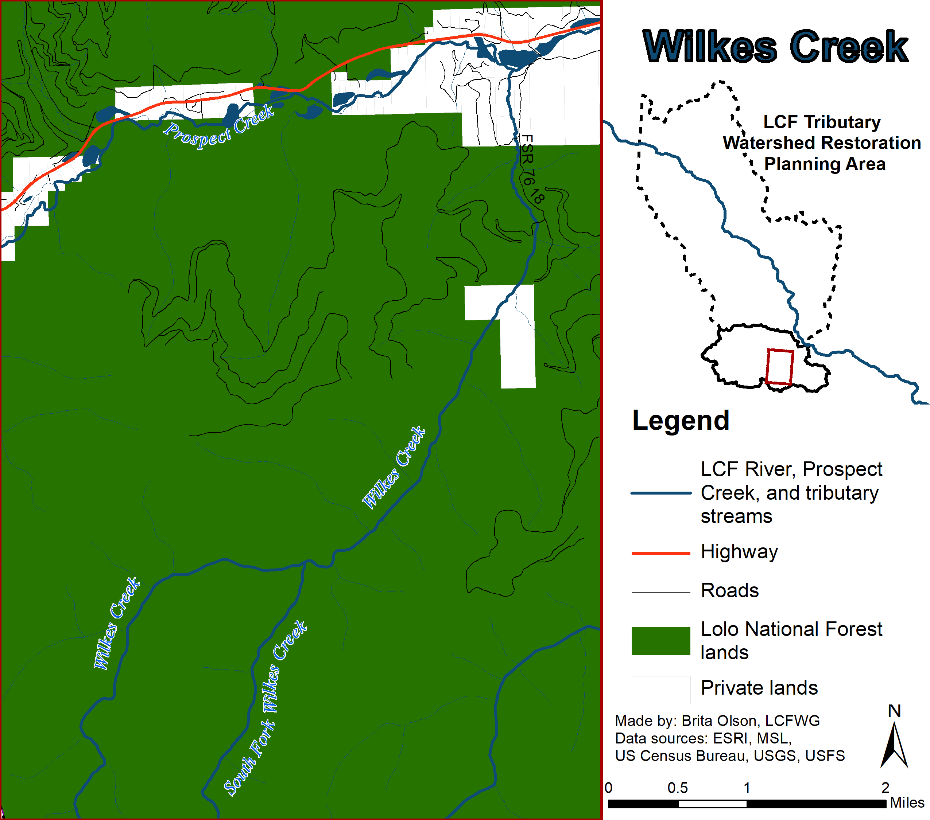
Wilkes Creek (Figure 2.9D) enters the lower mainstem Prospect Creek downstream of Crow Creek. Land use activities including upland and riparian timber harvest, road building, and residential development have all modified the stream corridor. FSR 7618 is the primary road in the lower subwatershed, while other roads traverse the uplands to the east and west of the stream corridor. The upper reaches of the subwatershed above a small section of private land are in near-reference condition, while the lower third of the subwatershed is impacted by riparian harvesting, extensive grazing, and two-track roads on the floodplain. A bridge crossing of the FSR 7618 over Wilkes Creek two miles upstream of its confluence with Prospect Creek constricts the channel. Approximately 1 mile of Wilkes Creek near the confluence is intermittent (GEI 2005).
Figure 2.9D. Wilkes Creek Subwatershed.
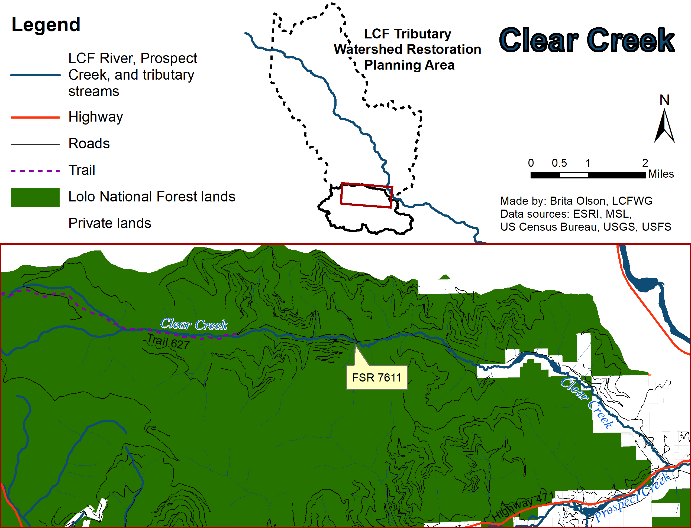
Clear Creek (Figure 2.9E) is a tributary entering lower mainstem Prospect Creek downstream of Wilkes Creek. This subwatershed has the highest amount of private land holdings (10%) which are primarily located in the lower reaches. Clear Creek is a highly developed subwatershed with multiple road systems throughout used for accessing timber harvest units. Road density is relatively high compared to other subwatersheds within the Prospect Creek watershed, with the highest densities of roads located in the lower and middle reaches; however, most of these roads are managed by the USFS and currently meet BMP standards. Upper Clear Creek within the USFS boundary is largely functional, while lower Clear Creek is slightly impacted by encroachment from a historical roadbed now used for Trail 627. Approximately 2 miles (3.2 km) of Clear Creek that ends 0.2 miles (0.3 km) above FSR 7611 has been impacted by riparian harvest on both sides of the stream. Little to no riparian buffer exists along much of this reach and channel width-to-depth ratios remain high, despite previous restoration efforts. Approximately 13,000 sheep grazed the lower Clear Creek subwatershed in 1917 and their presence negatively affected channel stability and the riparian vegetation communities. The grazing allotment discontinued in 1985. The Clear Creek subwatershed also naturally produces low to moderate sediment loads; however, anthropogenic changes have exceeded the creeks ability to adjust to impacts and the channel has become unstable in many locations, producing excess sediment (GEI 2005).
Figure 2.9E. Clear Creek Subwatershed.

A large intermittent reach is present within the middle portion of mainstem Clear Creek, beginning on private land and ending upstream on the USFS-LNF. Lower Clear Creek is currently functioning below cold-water fishery potential due to excess coarse sediment, high width-to-depth ratios, reduced canopy cover, reduced LWD and elevated stream temperatures. Clear Creek was previously understood to provide habitat for Bull Trout, but this should be reassessed as the dominance of Brook Trout in the lower perennial area and warm stream temperatures portray little value for Bull Trout rearing (RDG and USFS LNF 2004; Moran and Storaasli 2018).

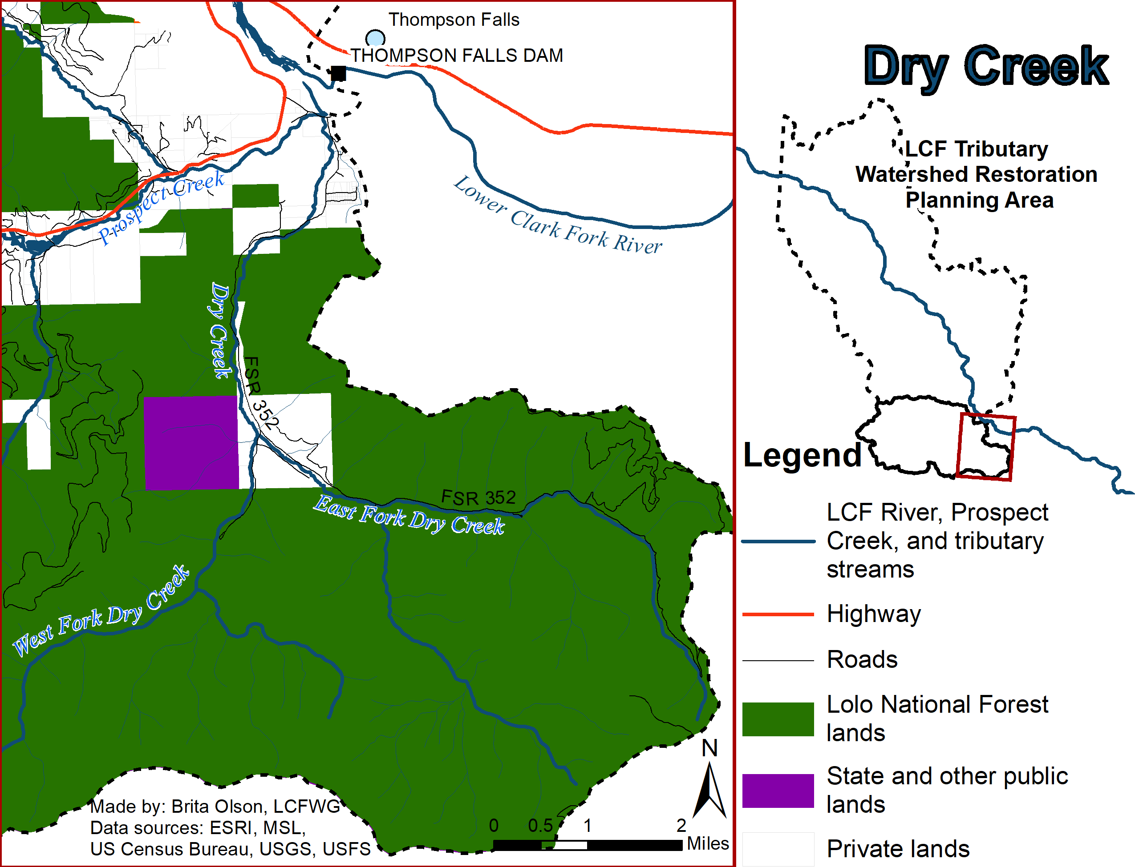
Dry Creek (Figure 2.9F) is the largest tributary to mainstem Prospect Creek, joining the mainstem near its confluence with the LCF River. Upland and riparian timber harvest, road building, grazing, and residential development (on private lands concentrated in the downstream reaches of Dry Creek and also within the vicinity of the confluence of East and West Fork Dry Creeks) have modified the stream corridor from its natural state. Forest Service Road 352 has encroached on the stream corridor, accelerating sediment loading into the channel. Dry Creek has extensive areas of seasonal intermittency throughout the middle reaches, which isolates an abundant population of Westslope Cutthroat Trout in the upper reaches (Moran 2004). The stream reemerges from the intermittent reach as cold water approximately 0.3 miles (0.5 km) upstream of its confluence with lower Prospect Creek, where the majority of the channel is simplified and flows through private pasture. These cold flows and proximity to the mouth of Prospect Creek have resulted in sporadic use by migratory Bull Trout for spawning, with a total of 12 redds observed over five of the last 15 years it has been surveyed (Moran and Storaasli 2018).
Figure 2.9F. Dry Creek Subwatershed.
Completed Projects for NPS Pollution Reduction and Native Fish Conservation (Horn 2011)

Project description | Cost | Date completed
Clear Creek stabilization and revegetation | unknown | 1997
Lower Prospect Creek Restoration – Phases 1 & 2 | $204,000 | 1999-2001
YPL Relocation/ Removal Reclamation | unknown | 2003
Daisy Creek Stream Rehabilitation | $6,200 | 2005
Crow Creek Restoration | $123,000 | 2007
Cooper & Chipmunk Culvert Replacement (Bridges) | $196,000 | 2007
Old Wilkes Creek Bridge Abutment Removal | $3,900 | 2008
Cooper Gulch LWD | $3,000 | 2009
Prospect Creek Riparian Re-Forestation | $29,204 | 2009
YPL Riparian Revegetation | $50,000 | 2009

Planned and Proposed Projects for NPS Pollution Reduction and Native Fish Conservation
Project description | Lead Entities | Related documents
Crow Creek Channel Restoration – Phase II | FWP, USFS-LNF, LCFWG | Blakney, J., In prep.
Cooper Gulch powerline and/or road relocation and channel enhancement | NWE, USFS-LNF, FWP, LCFWG | Jon Hanson, personal communication.
Upper Prospect Creek channel enhancement | FWP, LCFWG, TU | Jason Blakney, personal communication.

